OptOut from NEST SCHEME

- Click the below link

https://www.nestpensions.org.uk/schemeweb/NestWeb/faces/secure/USER_REG/pages/activateYourAccount.xhtml

- Enter below details like DOB, NEST ID, NI
- If you dont know your NEST ID click on ‘I dont have my NEST ID’
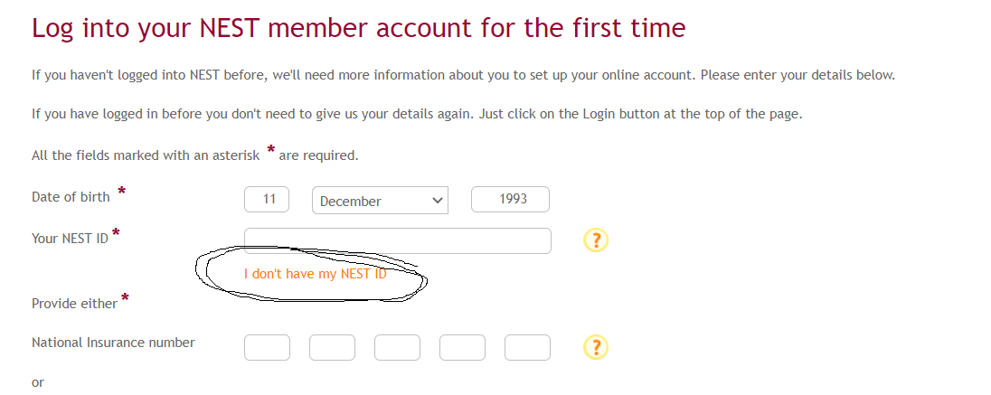

- Enter the details like DOB, NI, LAST NAME, GENDER as below, (some details hidden below for confidentiality) and click next
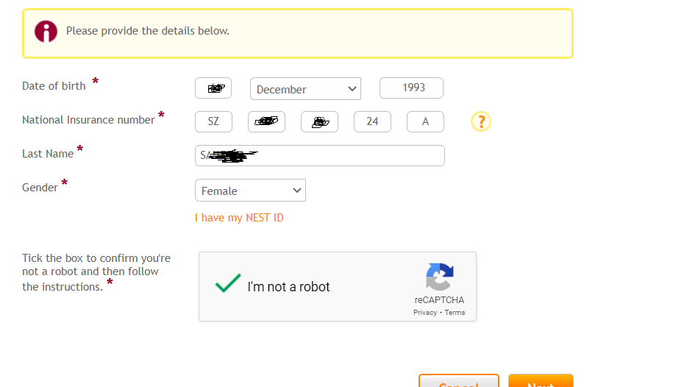

- You will get below screen for personal details,
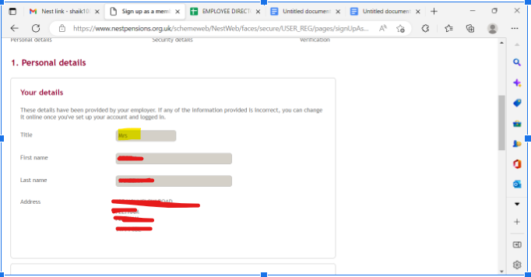

- Update your mobile number, email id and proceed further
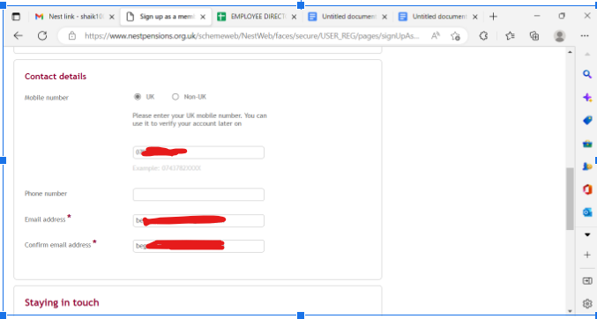

- In the next screen you will get your email id as username and click on check availability to confirm the userid (if this id already registered you need to change it and try)
\
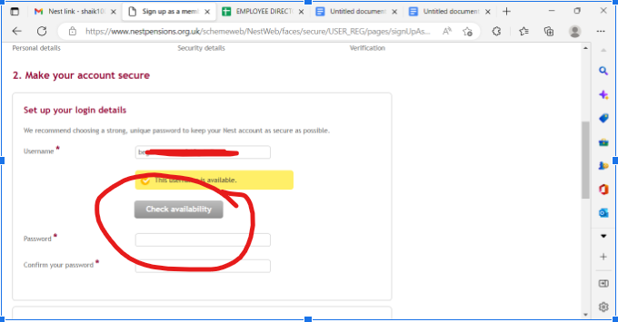

- Set password and confirm password

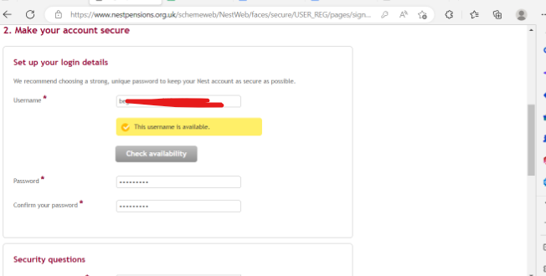

- Set any three secret questions which you can remember and you need these answers if you want to reset your account in future

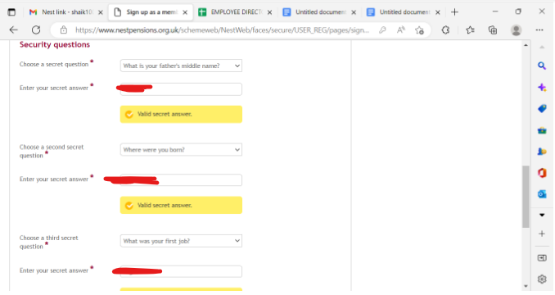

- Please confirm your mobile number with one time passcode sent to the phone and complete the application.

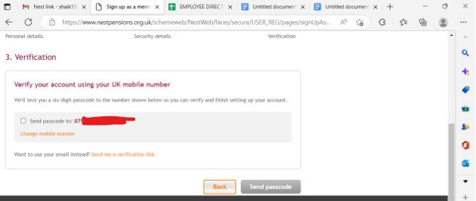

- Now you should log into your NEST account

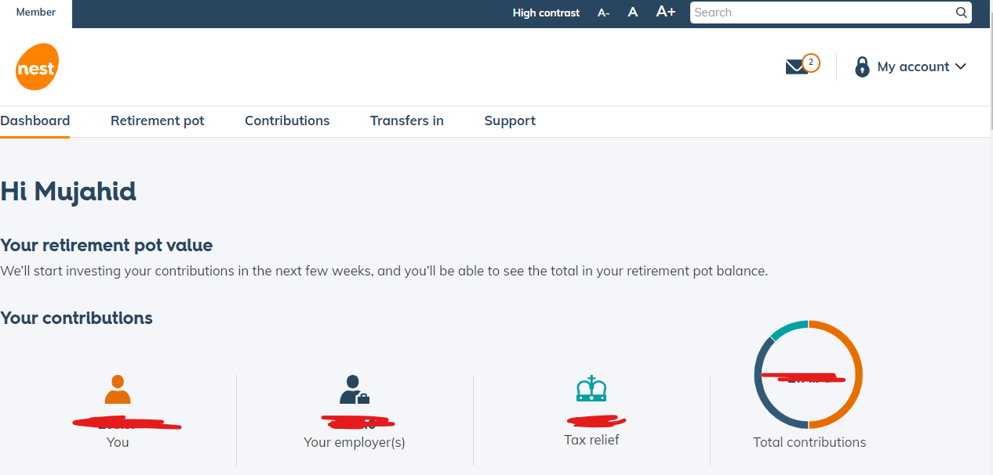

- Click on mail icon at right top corner
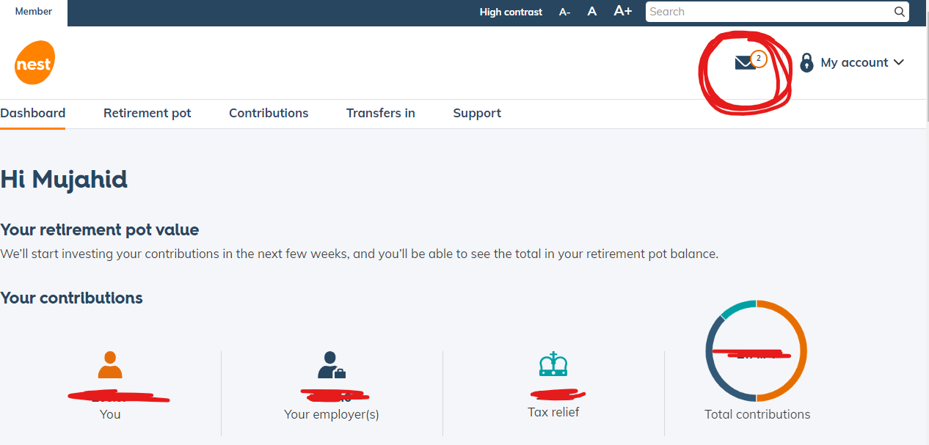

- You should have got email with Your national insurance details as below

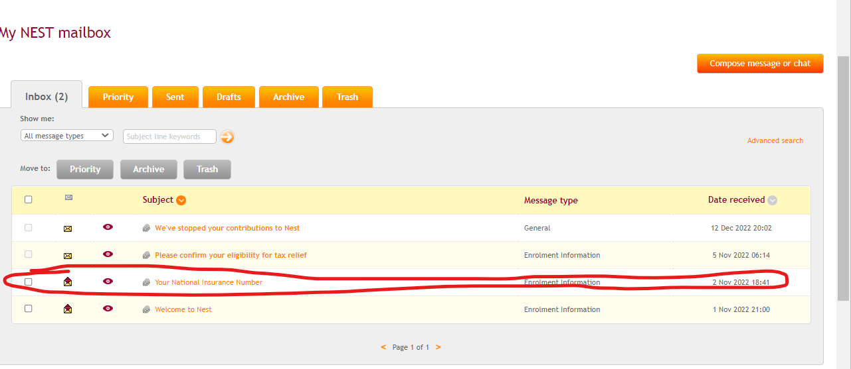

- Look for pdf attachment in that email

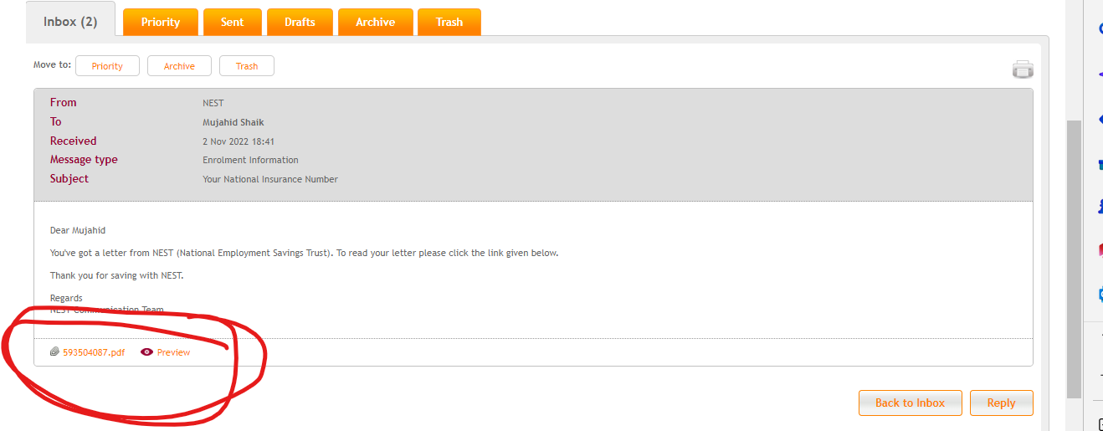

- Download and save it, in this document you can see your NEST ID

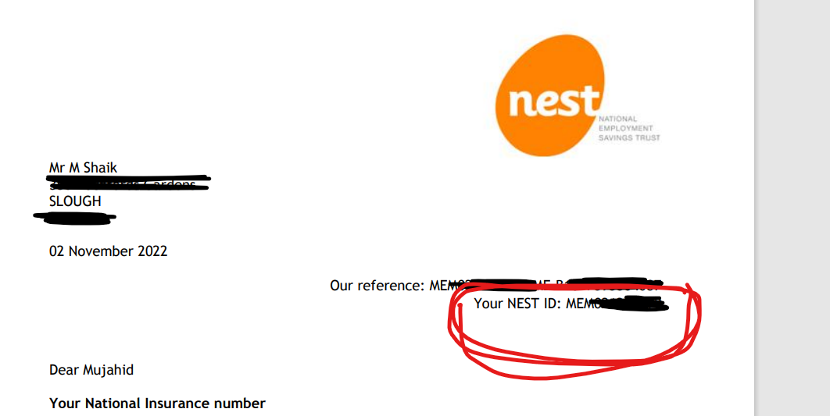

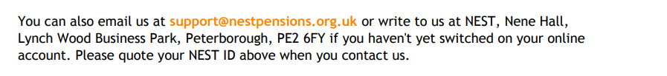

OPT OUT PROCESS

- In order to opt out from NEST, click on Dashboard

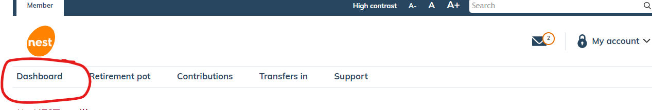

- Scroll down the page to see below option

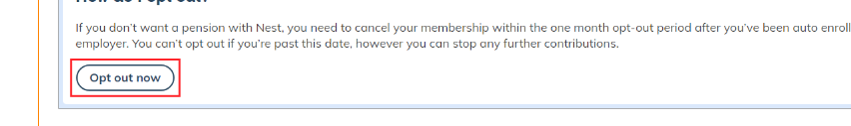

Click on opt out now.. It will ask for the reason ..select any reason which suits you and proceed to complete the process…

- If you dont see the Opt out option in dashboard page, then

Please call 03000200090 for stopping your contributions
- Keep NEST ID, NI number, SECRET QUESTIONS, email id, mobile number, home address handy before the call…

In the end you will get an email in your NEST mail box aswell as your gmail id

Like below

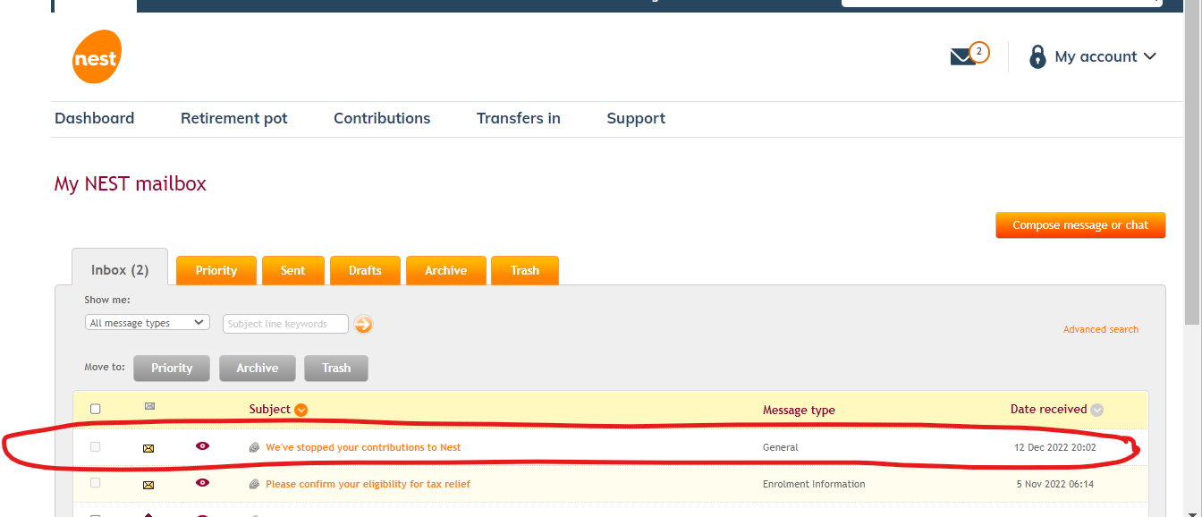

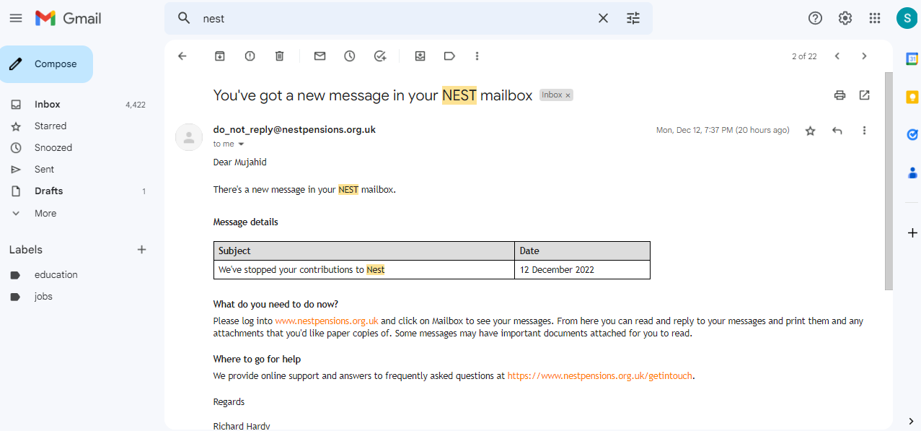

- If you were Opted out from the NEST SCHEME the account will be closed and amount will be deposited to employers account.
- If you were not able to opt out and only stopped the contribution then your account will be still active and you can transfer the amount to any future pension schemes (you or your family) or refunded after you reach 55 years of age.

